**Question # 01:**

Practice all the Linux commands discussed in this lab while taking assistance using the **man** command. Write the complete syntax used for utilizing the **cp**, **mv** and **rm** commands in Linux shell.

Copy:

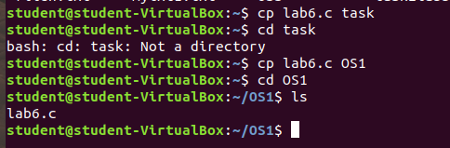

Move

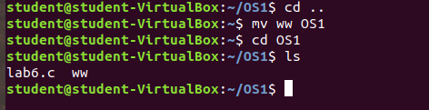

REMOVE:

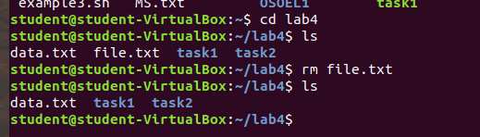

MKDIR:

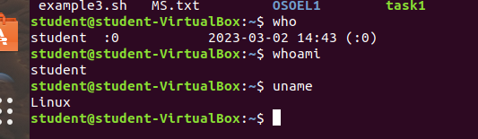

**Question # 02:**

Write the C programs to find the factorial of any number and generate their outputs over Linux environment.

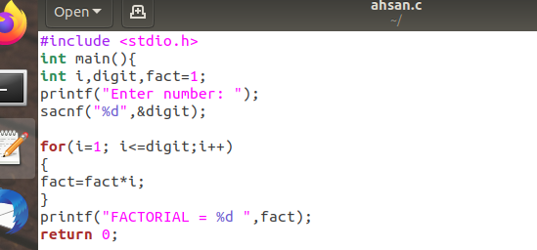

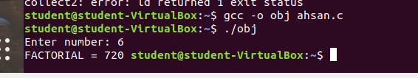

**Question # 03:**

Write a C program on the Linux environment that takes your marks as an input and display your grades accordingly to that followed at Bahria University. Limit your program to a maximum of five subjects. Use the suitable logical operator(s), i.e. and (&&), or (||), not (!), if required.

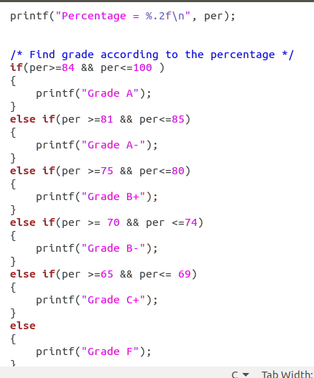

**OUTPUT**

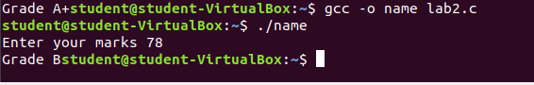

**Question # 04:**

Write a shell script to display your address over multiple lines.

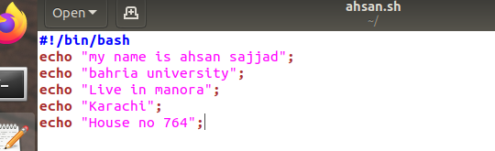

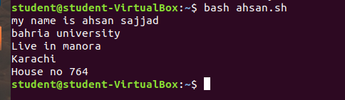

**Question # 05:**

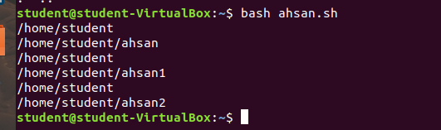Write a shell script that would traverse among any three directories that are placed under the /home directory. While moving from one directory to another, the script should display the name of the current working directory and list the content within that directory, including the hidden files